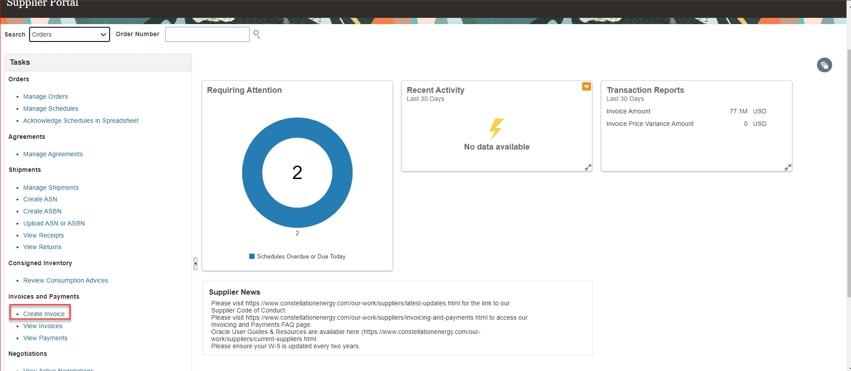
The Oracle Supplier Portal allows you to apply credit memos to Purchase Orders (PO). From the Portal Home screen click on Supplier Portal to be routed to the work area. From there, navigate to the Create Invoices task on the left-hand side of the page.
Click Create Invoice and from the Create Invoice screen on the right side make sure the drop down next to Type is changed from Invoice to Credit Memo by clicking the down arrow and selecting Credit Memo
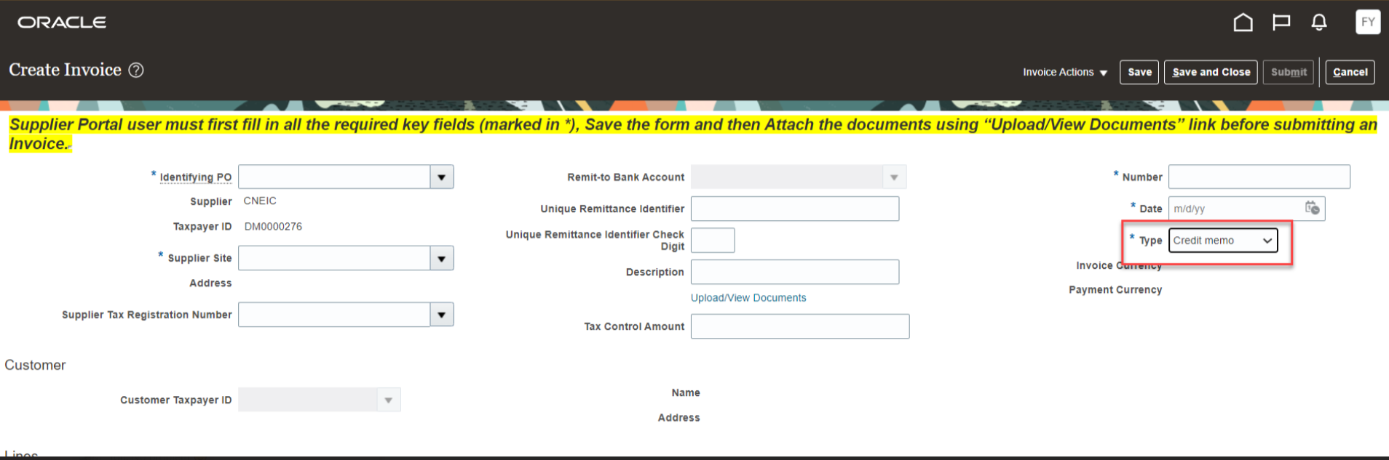

Just like the create invoice process you will need to fill out the below fields:
*Identifying PO
*Supplier Site
*Number - credit memo number
*Date - date the credit memo is issued
Attachment - please be sure to include an attachment of the credit memo.
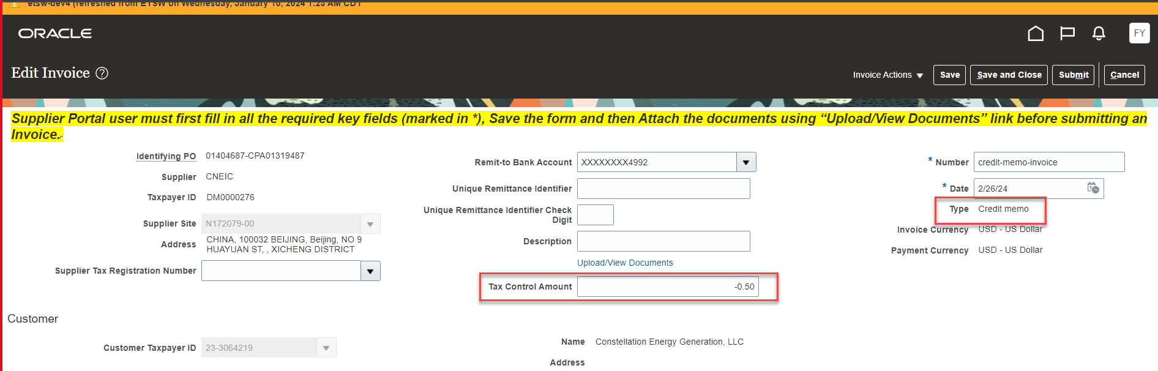

Once you have selected the appropriate purchase order, scroll down to the Lines section of the form, click on the plus sign that is on top of a piece of paper to add the appropriate lines that the credit memo should be applied to.
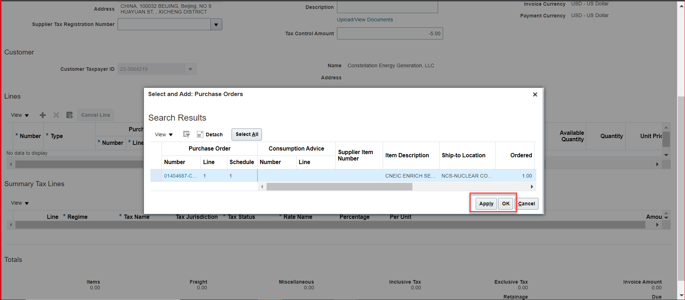

From here you can choose Select All if the credit memo should be applied against all lines on the purchase order or you can select only specific items that apply. To select individual lines, highlight them by clicking in the box to the left of the PO number. Then click Apply and OK. This will take you back to the previous Lines screen with the line(s) you selected. The system will automatically fill out the full amount as a credit. If this needs to be modified, please update the amount by scrolling to the right.

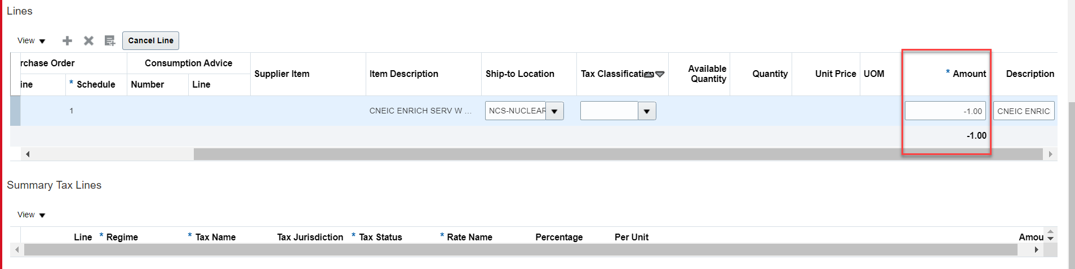
Once you have ensured that all the information and amounts are correct please scroll to the top of the page and click calculate tax from Invoice Actions.
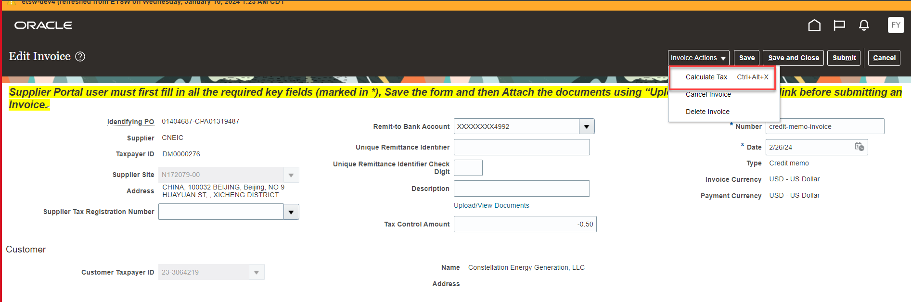
Validate the Tax Information in case vendor charged tax
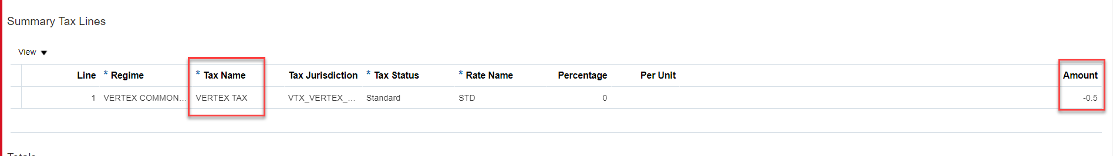

Note: If the vendor does not charge tax, the tax control amount should not be entered.

Once you have ensured that all the information and amounts are correct, please scroll to the top of the page and click submit. This will route the credit memo to the AP team for processing.
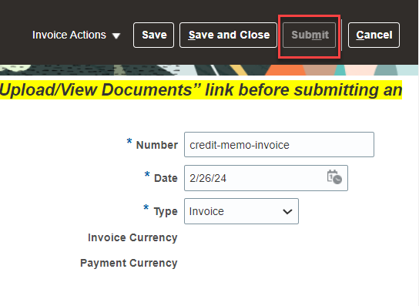
You will get a notification showing that the Credit Memo has successfully been submitted.
